STW104KM: Enterprise Information Systems

Marking Scheme

This marking scheme has been prepared as a guide only to markers. This is not a set of model answers, or the exclusive answers to the questions, and there will frequently be alternative responses which will provide a valid answer. Markers are advised that, unless a question specifies that an answer be provided in a particular form, then an answer that is correct (factually or in practical terms) must be given the available marks.
Throughout the marking, please credit any valid alternative point.

Where markers award half marks in any part of a question, they should ensure that the total mark recorded for the question is rounded up to a whole mark.

Question 1.
A car rental is a vehicle that can be used temporarily for a period of time with a fee. Renting a car assists people to get around even when they do not have access to their own personal vehicle or don't own a vehicle at all. The individual who want to rent a car must first contact the car rental company for the desire vehicle. This can be done online. At this point, this person has to supply some information such as; dates of rental, and type of car. After these details are worked out, the individual renting the car must present a valid Identification Card.
Most companies throughout the industry make a profit based on the type of cars that are rented. The rental cars are categorized into economy, compact, compact premium, premium and luxury. And customers are free to choose any car of their choice based on their purse and availability of such car at the time of reservation. Car Rental System gives car rental service for both foreign and local customers. This organization carries out its daily work by providing; their service to the customers using manually system. The organization uses a manual system for reserving, renting, register and to keep record of all the rental activities and customer information.
The detailed existing system functions are listed as follows –

- During car reservation the customers reserve a vehicle by making a phone call to the organization; otherwise he/she is expected to go to the organization to make reservation.
- During renting a car the customer personal information, payments status and rent agreements are filled in the car rent agreement form in order to hold legal contract between the customer and organization for renting the vehicle.
- The organization normal work time schedule is from 1:30am – 6:00pm; therefore, the organization gives services for ten and half hours a day.
- The organization makes a general report about the rented cars once at the end of the month and generates a report.

Product functionality:
Car Rental System provides the features for booking a car online. It includes several functionalities describes as below:
Car Rental Management:
It provides car reservation facility online. Customer can visit the website and check for various cars. If they are feasible with requirement, then booking can be done.
Checking for Availability:
Employee can check for the availability of the car. He/she maintains the database of car. If no any car is available, it is the responsibility of the employee to provide alternative options.
Payment system:
Administrator/owner of the applications responsible for payment to the employee. Order cancellation, order finalize, these all activities are done by the administrator of the application
Maintenance Manager:
If any car requires maintain ace like repair or replacement of any parts, then maintenance manager maintain the data about that. Payment of maintenance are done by the administrator of the application.
Users and Characteristics:
Admin:
- Admin can login to the system.
- Verify the car information database.
- Generate price strategy.
- Handle the payment system.
- Finalize the order.
- Cancel the order.
Employee:
- It updates the database.
- Give information to the customer about the car.
- Provides the alternatives.
- Maintain contacts.

Maintenance Manager:
- It checks for the maintenance.
- Give to the maintenance.
- Give information to the admin.
- Update the database.

Customer:
- Customer can login to the system.
- Visit the website.
- Place the order.
- Cancel the order.

Functional Requirements:
These are statements of services the system should provide, how the system should react to particular inputs, and how the system should behave in particular situations. It specifies the application functionality that the developers must build into the product to enable users to accomplish their tasks.
Reservation:
- The system must allow the customer to register for reservation.
- The system shall allow the customer to view detail description of particular car.
- The system must notify on selection of unavailable cars while reservation.
- The system shall present an option for advanced search to limit the car search to specific categories of car search.
- The system must allow the customers to select specific car using different search category while reservation.
- The system must view list of available car during reservation.
- The system shall allow the customers to cancel reservation using reservation confirmation number.
- The system shall allow the employee to update reservation information.
- The system shall allow the employee to view reservations made by customers.
- The system shall present information on protection products and their daily costs, and requests the customer to accept or decline regulation terms during reservation.
- The system must be able to provide a unique reservation conformation number for all successfully committed reservations.
- The system must be able to display reservation summary for successfully committed reservation.

Log in:
- The system should allow manager to login to the system using their username and password.
- The system should allow employee to login to the system using their username and password.
- The system shall allow the manager to create new user account.
- The system shall allow manager to change account password.
- The system shall allow staff to change account password.
- The system shall allow staff to logout.
- The system shall allow manager to logout.

Car:
- The system should allow staff to register new cars.
- The system shall allow staff to select cars in the list.
- The system shall allow customer to select cars in the list.
- The system shall allow staff to Search cars by specific record.
- The system shall allow customer staff to Search cars by specific record.
- The system shall allow staff to update information of the car in need of modification.
- The system shall allow staff to display all lists of car.
- The system shall allow staff to display all available car.
- The system shall allow customer to display all available car.
- The system shall allow staff to display all rented car.
- The system shall allow staff to display all off duty car.
Rent:
- The system shall allow staff to register customers into rental list.
- The system shall allow staff to update about customer rent record details in the rental list.
- The system shall be able to save all changes made on the customer rent list.
- The system shall allow staff to select customer rent record by specific search category.
- The system shall allow staff to search rent record of customers using specific categories.
- The system shall allow staff to display customers, who rent cars.
- The system shall allow staff to display all customers rent record.
- The system must provide printable summary for successful committed rent.

On the basis of above details complete the following task.

Task 1: Draw the Activity Diagram for placing the order
marks (2)

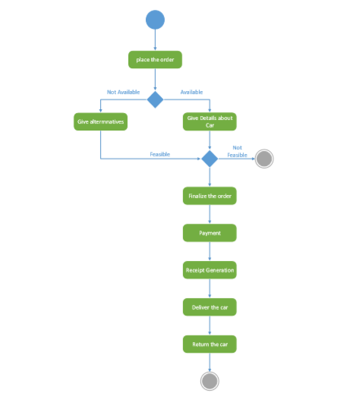

Task 2: Draw the Activity Diagram for Member Registration
marks (2)

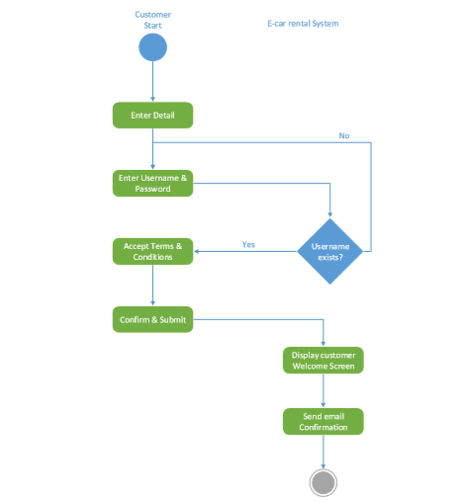

Task 3: Profile Modification Login
marks (2)

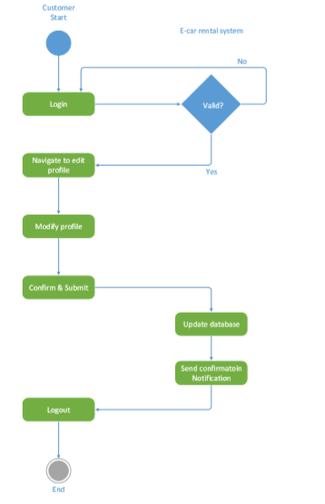

Task 4: Draw the Activity Diagram Reservation of Car

marks (2)

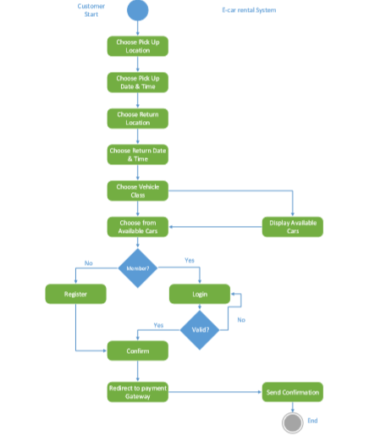

Task 5: Draw the Activity Diagram of Custoemer feedback

marks (2)

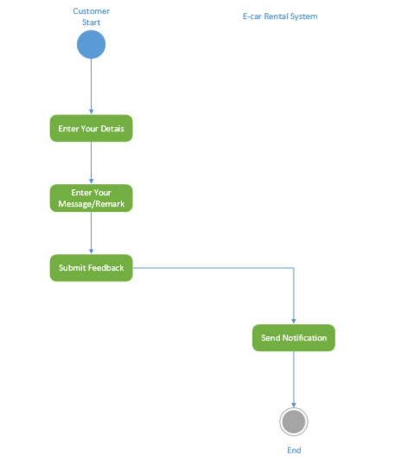

Task 6: Draw the Activity Diagram of Payment of Car Rent
marks (2)

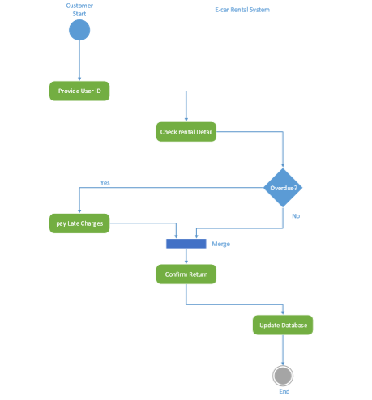

Task 7: Draw the Activity Diagram of Adding a New Car

marks (2)

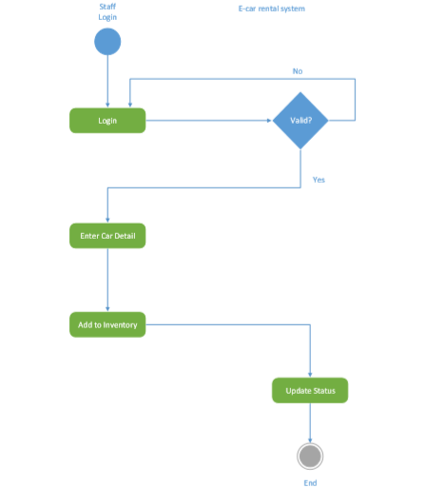

Task 8: Draw the Activity Diagram of View Report
marks (2)

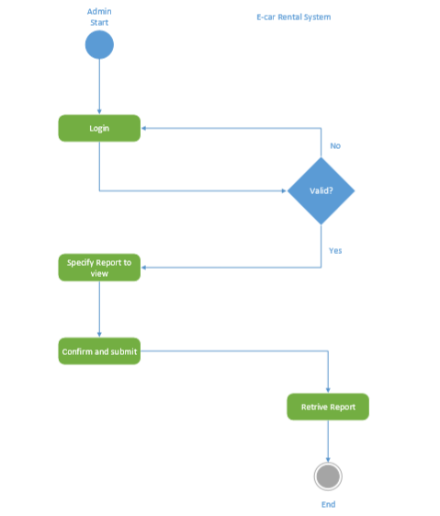

Task 9: Draw the Diagram of Actors and Use Case description
marks (2)

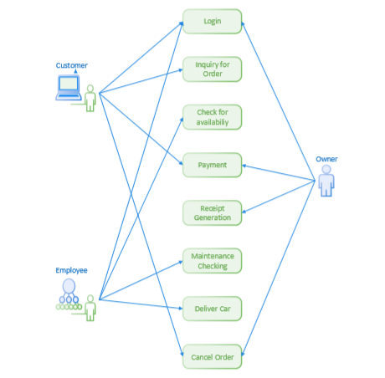

Actor and use case description shows the detail description of interaction between the actors and their use cases. The description enables to have a proper understanding of how actor interacts with the system through their use cases.

Task 10: Swim Lane Diagram
marks (2)

The swim lane flowchart differs from other flowcharts in that processes and decisions are grouped visually by placing them in lanes. Parallel lines divide the chart into lanes, with one lane for each person, group or sub process. Lanes are labelled to show how the chart is organized.
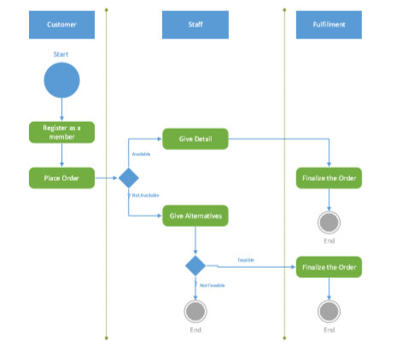

Task 11: Sequence Diagram
marks (2)

Sequence diagrams are used to demonstrate the behavior of objects in a use case by
describing the objects and the messages they pass. It provides a graphical representation of object interactions over time. Sequence diagrams show an actor, the objects and components they interact with in the execution of a use case. One sequence diagram represents a single Use Case 'scenario' or events. Sequence diagrams show the flow of messages from one object to another, and as such correspond to the methods and events supported by an object.

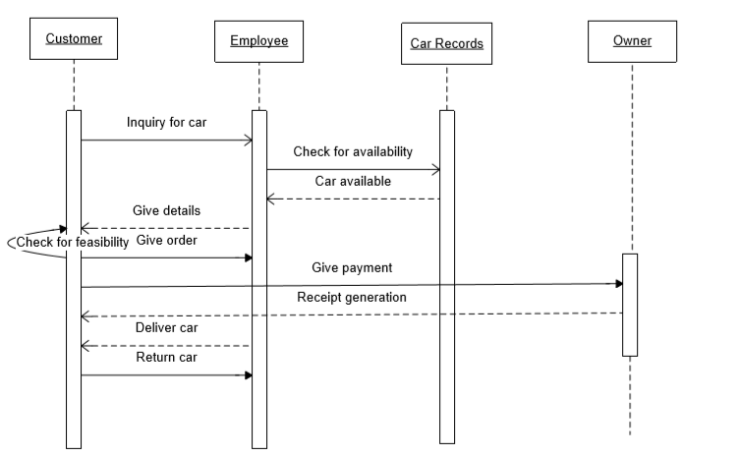

Task 12: Entity–relationship model
marks (4)

The entity relationship diagram describes the relationship between entities, cardinality and their attributes.
Entity–relationship model (ER model) is a data model for describing the data or information aspects of a business domain or its process requirements, in an abstract way that lends itself to ultimately being implemented in a database such as a relational database.
The main components of ER models are entities (things) and the relationships that can exist among them.
In here we provide a description of entities with all their attributes.
Describing entity name, business definition for the entities and their attribute and domain.

Entity Description:

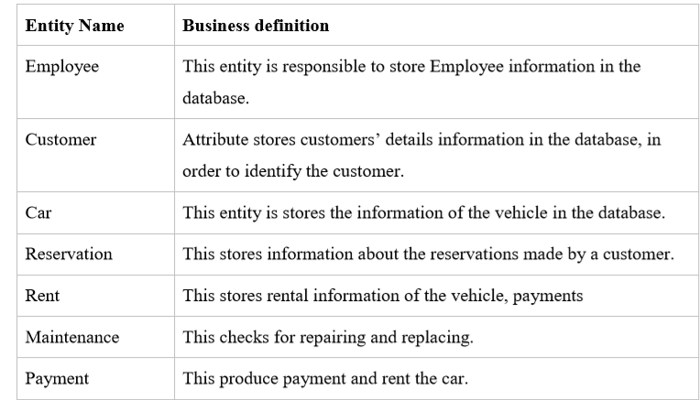

E-R Diagram

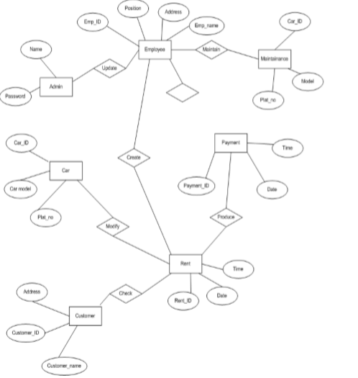

Task 13: Data flow diagram

marks (4)

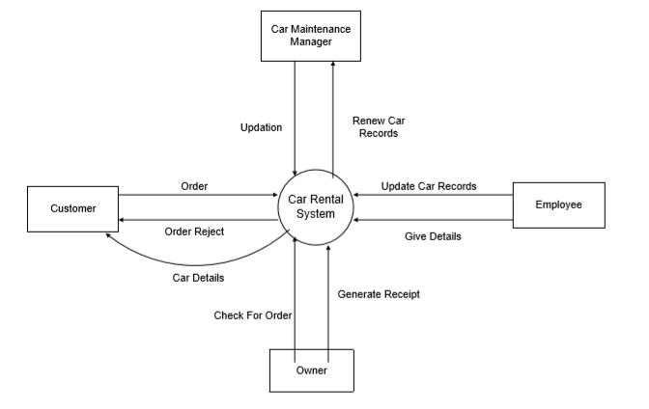

- The Customer (a source of information) sends in an order.
- The system then sends out an invoice data flow.
- Employees update car records and give details to the car rental system.
- Car maintenance manager gets information about cars from the system, update the renewed records.
- The owner checks for order and generates report.
- This is a top-level view of the information flow in and out of the system.

